|  |
| --- |
| NAME: Ayush Vinod Upadhyay  ROLL NO: I025  SAP ID: 60003220131  BRANCH: Information Technology |

**Experiment No:9**

**To implement triggers**

**------------------------------------------------EXERCISE--------------------------------------------**

1.

|  |
| --- |
| CREATE TABLE employee(  empno INTEGER,  fname VARCHAR(20),  lname VARCHAR(20),  salary NUMBER,  address VARCHAR2(50)  ); |

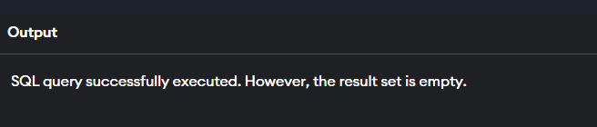

|  |
| --- |
| INSERT INTO employee VALUES(101, 'RAHUL', 'BALA', 1234.56, '3F GREENS MULUND');  INSERT INTO employee VALUES(102, 'Romeo', 'Singh', 5434.56, '4F GREENS MULUND');  INSERT INTO employee VALUES(103, 'Real', 'Adani', 10000.56, '5F GREENS MULUND'); |

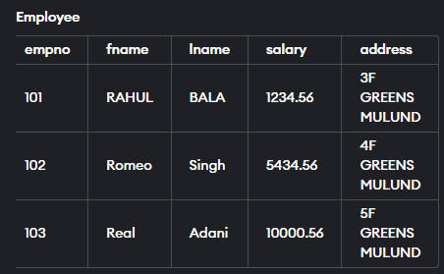

|  |
| --- |
| CREATE TABLE backup_employee(  empno INTEGER,  fname VARCHAR(20),  lname VARCHAR(20),  salary NUMBER,  address VARCHAR2(50)  ); |
| CREATE TRIGGER t1  AFTER UPDATE OF salary ON employee  FOR EACH ROW  BEGIN  INSERT INTO backup_employee(EMPNO, SALARY) VALUES(OLD.empno, OLD.salary);  END; |

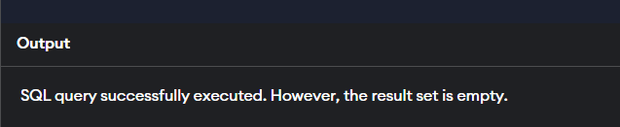

|  |
| --- |
| UPDATE employee  SET salary = 1000  WHERE empno = 101; |

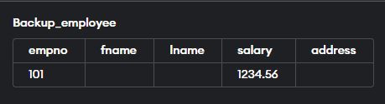

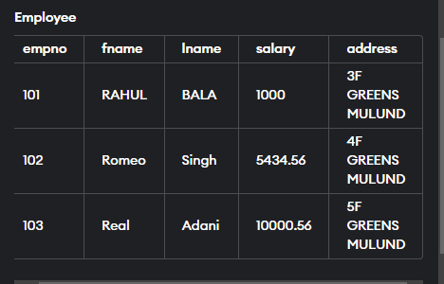

|  |
| --- |
| SELECT abs(employee.salary - backup_employee.salary) AS salary_difference  FROM employee, backup_employee  where employee.empno = backup_employee.empno; |

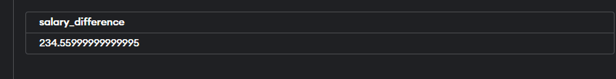

|  |
| --- |
| DELETE FROM backup_employee; |

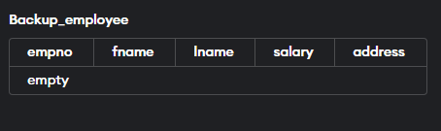

**2)**

|  |
| --- |
| CREATE TABLE GRADES(  SENo NUMBER,  M1 NUMBER,  M2 NUMBER,  M3 NUMBER,  Avg_M NUMBER  ); |
| CREATE TRIGGER GRADES_TRG  AFTER INSERT ON GRADES  FOR EACH ROW  BEGIN  UPDATE GRADES  SET AVG_M = (M1 + M2 + M3)/3 ;  END;  INSERT INTO GRADES(SENo, M1, M2, M3) VALUES(100, 89, 90, 80); |

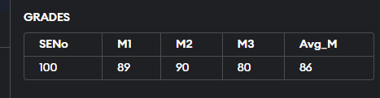

|  |
| --- |
| INSERT INTO GRADES(SENo, M1, M2, M3) VALUES(101, 99, 90, 20); |

